**BY : Amira Mohammed Mohammed**

**About Data**

🔹 **Categorical Features:**

* **school, sex, address, famsize, Pstatus** → Student demographics.
* **Mjob, Fjob, reason, guardian** → Parental background.
* **schoolsup, famsup, paid, activities, nursery, higher, internet, romantic** → Educational support & social factors.

🔹 **Numerical Features:**

* **age, Medu, Fedu, traveltime, studytime, failures** → Personal & academic background.
* **famrel, freetime, goout, Dalc, Walc, health, absences** → Lifestyle & behavior.
* **G1, G2, G3** → Student grades (Key target variables).

🔹 **Use Case:**  
Helps analyze factors affecting student performance and build predictive models.

**Dataset Link**

**<https://www.kaggle.com/datasets/larsen0966/student-performance-data-set>**

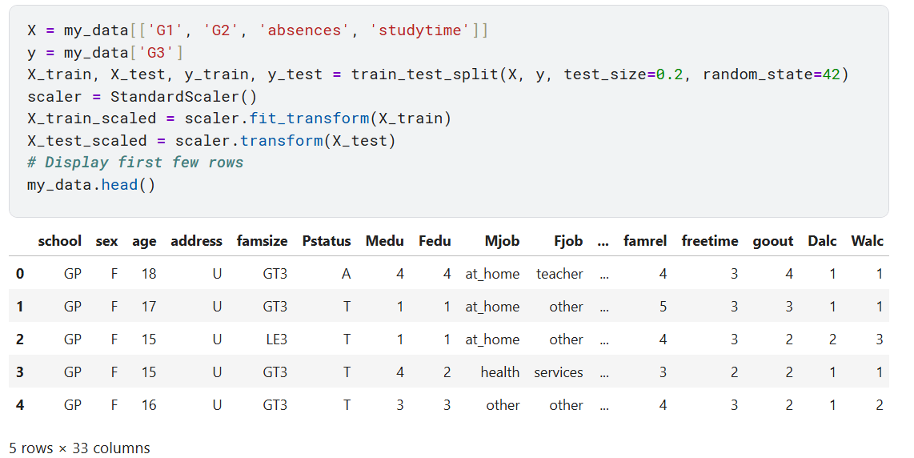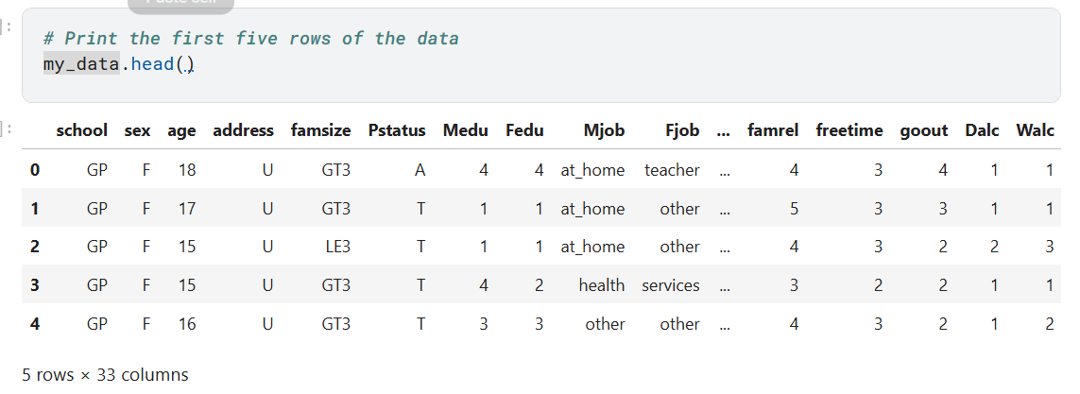

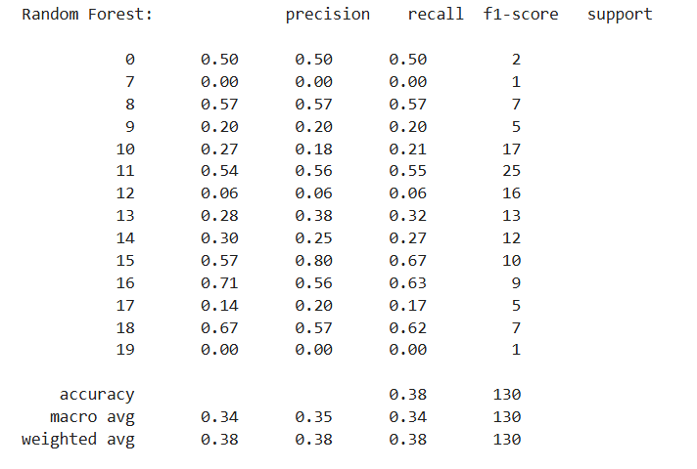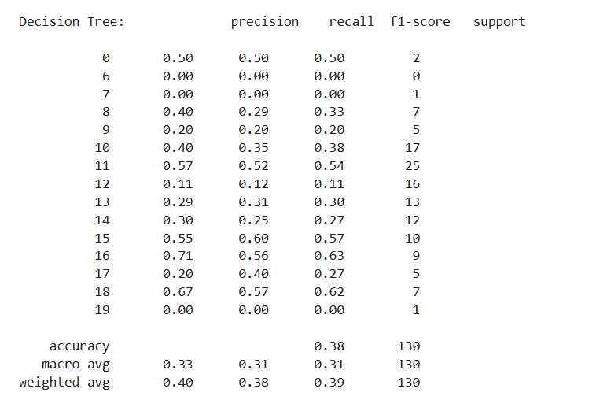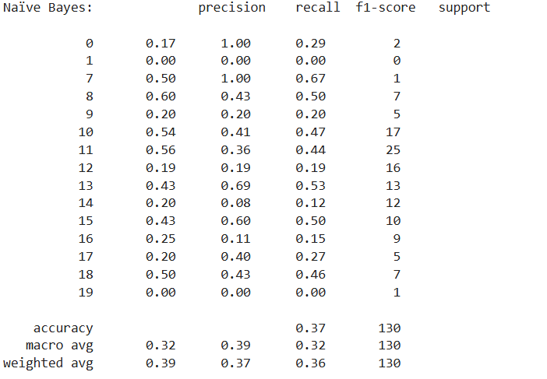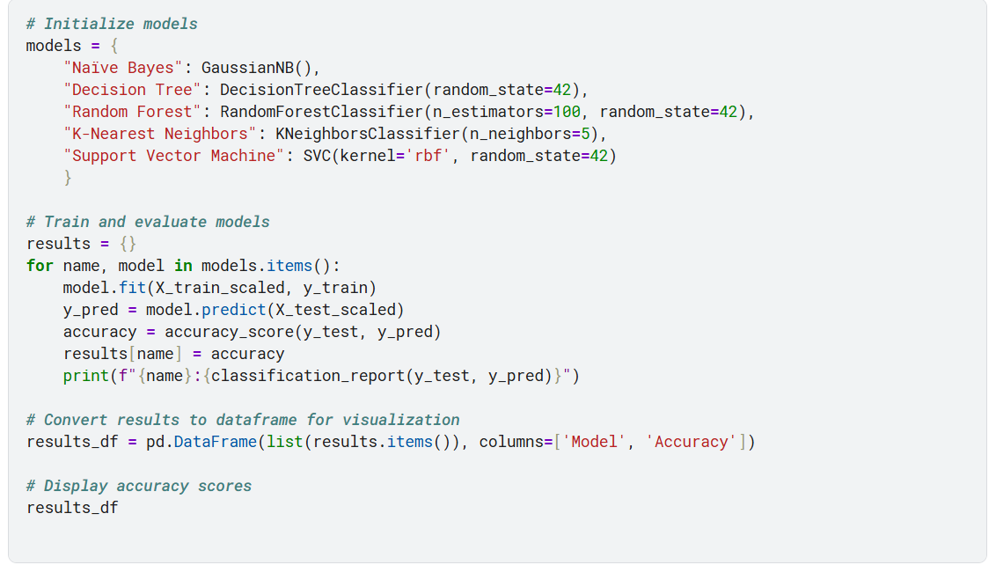

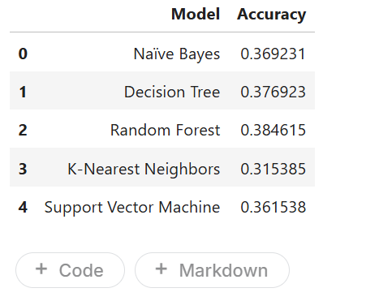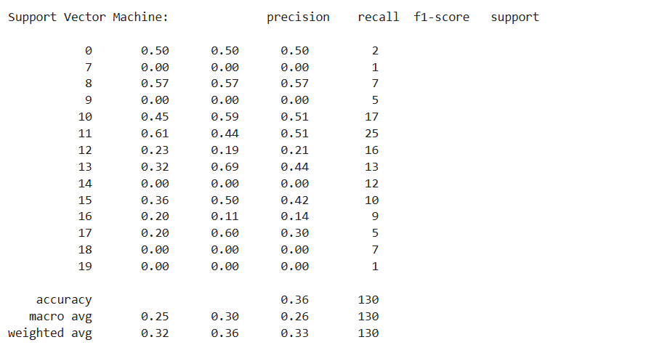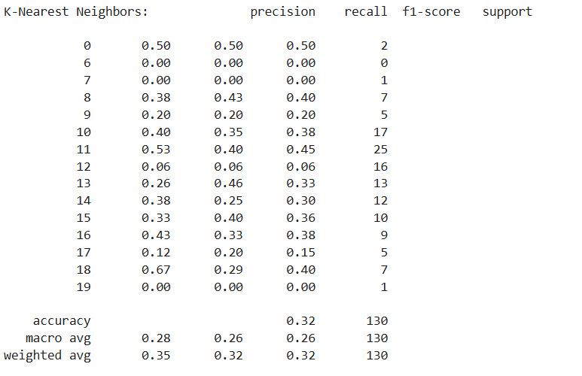

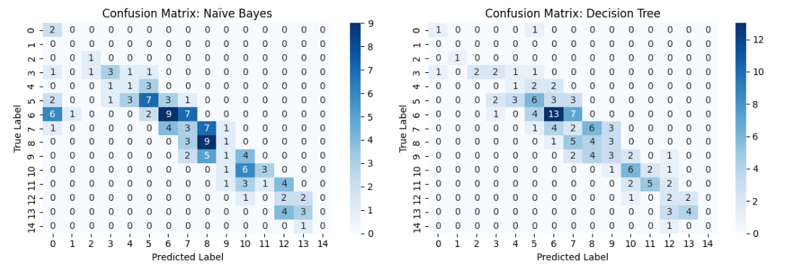

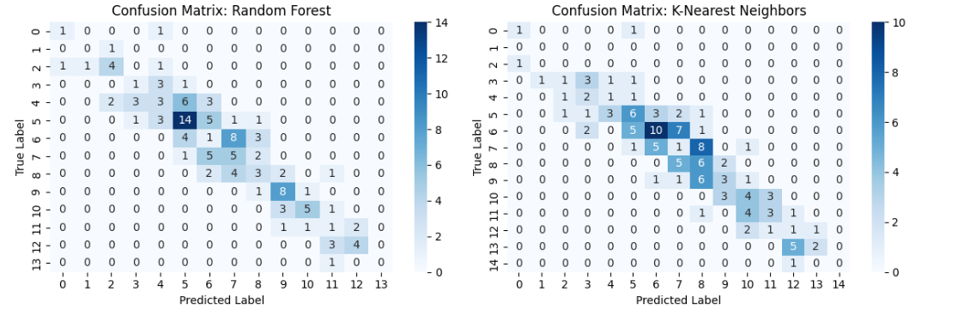

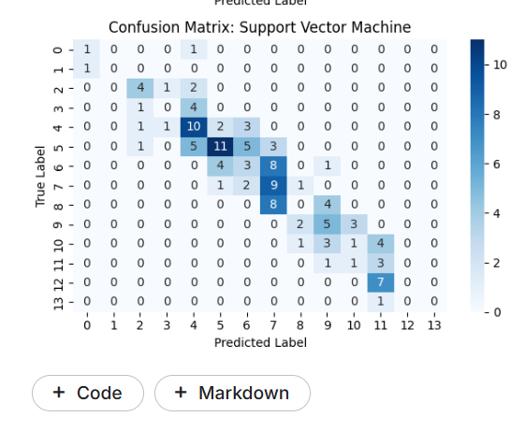

**Conclusion**

* **SVM** achieved the highest accuracy among the models.
* **Random Forest** and **Decision Tree** performed well, while **Naïve Bayes** and **KNN** had lower accuracy.
* **Confusion matrices** highlight misclassifications and model performance visually.